*Florida International University*

*School of Computing and Information Sciences*

CIS 4911 - Senior Capstone Project

Software Engineering Focus

Feature Document

User Story # 634

**Team Member:**

Garrett Lemieux

**Product Owner(s)**:

Francisco Ortega

**Mentor(s)**:

Francisco Ortega

**Instructor**: Masoud Sadjadi

**User Story - Enable device’s connection status**

* As a User I would like to be informed which devices are enabled in order to know what modes can be chosen and actions that can be made.
* **Acceptance Criteria**:

1. User Interaction UI must dynamically update when a device has been connected or disconnected.
2. Modes must be updated automatically and actions be enabled or disabled dynamically.

**Use Case: User needs control of enabled devices**

User wants to be informed which devices are enabled and be able remove a device with feedback.

* Details:
* Actor:
  + User
* Pre-conditions:
  + TouchPoint app is running.
* Description:
  + Use case begins device has been connected or disconnected at any point application is running.
  + User can view connection status of devices within the UI display
  + Use case ends when user exits application.
* Post-conditions:
  + Blue rectangle should be present in UI display when Multi-Touch device is connected.
  + Blue rectangle should be absent in UI display when Multi-Touch device is not connected.
  + Green rectangle should be present in UI display when Leap Motion device is connected.
  + Green rectangle should be absent in UI display when Leap Motion device is not connected.
  + Purple rectangle should be present in UI display when EyeX device is connected.
  + Purple rectangle should be absent in UI display when EyeX device is not connected.
* Decision Support:
  + Frequency: High, User will need to know at all times what devices are connected.
  + Criticality: High, User will need information of device connection in order to properly use application.
  + Risk: High , Have to use libUsb library
* Usability:
  + User need to know what icons represent each device and how to pull up the Ui display.
* Reliability
  + High
* Performance
  + Performance High , low failure
* Supportability
  + Multi-touch Screen (ACER)
  + Leap Motion Device
  + EyeX
* Modification History:
  + Owner: Garrett Lemieux
  + Initiation Date 3/01/2016
  + Date last Modified: 5/5/2016

**Use Case Diagram**

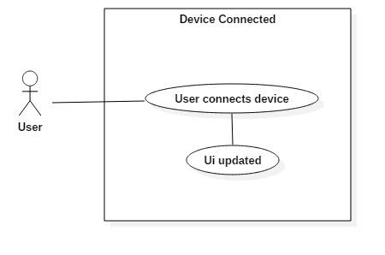

**Sequence Diagram**

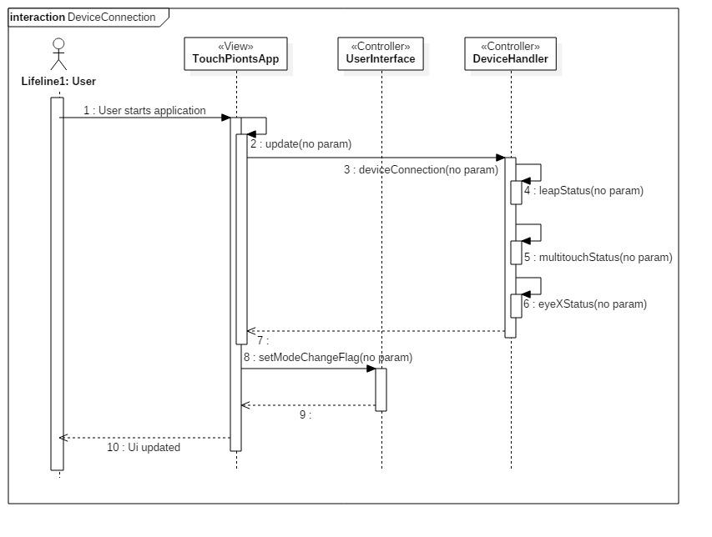

**Class Diagram**

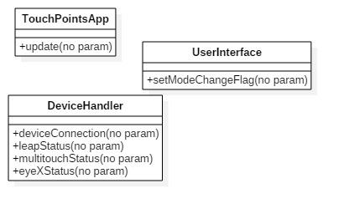

**Unit Test**

* Sunny Day Test:
  + Test Case  - Leap Motion Connection
    - Test Purpose: To determine if user is provided feedback about leap motion connection status.
    - Test Procedure: User plugs in leap motion device and starts program.

Then he or she checks Ui display.

* + - Expected Results: Green box should appear in Ui display.
  + Test Case  - Multi Touch Connection
    - Test Purpose: To determine if user is provided feedback about multi touch connection status.
    - Test Procedure: User plugs in Multitouch device and starts program.

Then he or she checks Ui display.

* + - Expected Results: Blue box should appear in Ui display.
  + Test Case  - EyeX Connection
    - Test Purpose: To determine if user is provided feedback about eyeX connection status.
    - Test Procedure: User plugs in eyeX device and starts program.

Then he or she checks Ui display.

* + - Expected Results: Red box should appear in Ui display.
* Rainy Day Test:
  + Test Case  - User unplugs Leap Motion or device fails
    - Test Purpose: Test if correct feedback provided if user unplugs leap motion or device fails.
    - Test Procedure: User unplugs leap motion while application running.
    - Expected Results: Green box should disappear. If green box remains in Ui display test fails.
  + Test Case  - User unplugs Multi Touch or device fails
    - Test Purpose: Test if correct feedback provided if user unplugs multi Touch or device fails.
    - Test Procedure: User unplugs multi Touch while application running.
    - Expected Results: Blue box should disappear. If blue box remains in Ui display test fails.
  + Test Case  - User unplugs eyeX or device fails
    - Test Purpose: Test if correct feedback provided if user unplugs eyeX or device fails.
    - Test Procedure: User unplugs eyeX while application running.
    - Expected Results: Red box should disappear. If red box remains in Ui display test fails.

**Integration Testing**

* The ability to user to know if devices have been connected or disconnected is automatically updated. User is provided feedback and application is not dependent on any device. Device feedback given for every device and are independent of each other.

**User Guide**

* In order for user to gain feedback from application he or she must enable Ui display  by using radial menu or by using keyboard.
* Once Ui display is present then the User will be informed of each device connected by small box in left hand corner of Ui display and box has specified color.
  + Green - Leap Motion

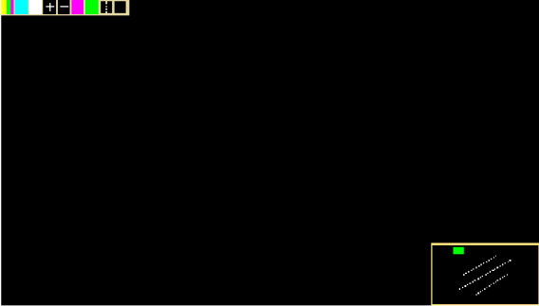

* + Blue - Multi Touch
  + Red – Tobii Eyexx